BOMBAY SAPPERS ASSOCIATION
MINUTES OF 47th MANAGEMENT COMMITTEE
MEETING (MCM) HELD ON 02 JUL 2016

1. 47th meeting of the Management Committee of Bombay Sappers Association (BSA) was held on 02 Jul 2016 at 1100 hrs in the Hall of Generals at BEG & Centre. The meeting was chaired by Brig Dhiraj Mohan, Vice-Chairman, Comdt BEG & Centre, Kirkee, Pune-03.

2. Following were present: -

(a) Maj Gen SCN Jatar (Retd) - Hon Gen Secy
(b) Maj Gen S D Sohoni (Retd) - Member
(c) Maj Gen S G Pitre (Retd) - Member
(d) Brig S R Mazagaonkar (Retd) - Director, BSA
(e) Col Anil Negi - Secy -cum –Treasurer
(f) Col Mohit Nangia - CO Depot Bn/ Member
(g) Lt Col M Salaskar - Accounts Officer / Member
(h) Sub Maj (H’Capt) V Lawate(Retd) - Member
(j) Sub Maj BR Fonde - Asst Secy

3. The Director asked permission to proceed with MCM.

4. At the outset the director welcomed Sub Maj B R Fonde, Gp SM who has joined the Management committee of BSA as Asst Secy. The Director gave out details of Sub Maj B R Fonde’s chequered career in the Bombay Sappers and said that he was sure that Sub Maj Fonde will contribute positively to BSA.

Agenda for MCM

5. The Director gave out the agenda of points to be discussed in this MCM.

(a) Approval of minutes of 46th MCM.
(b) State of latest strength of BSA Members.
(c) Details of boards held after the 46th MCM in FY 16-17.
(d) Final status of Income/expenditure incurred in FY 2015-16.
(e) CA Audit report for FY 2015-16.
(f) Review of annual budget 2016-17 to be presented in AGM.
(g) Donation received from Capt. Raghesh Dasannacharya (Retd).
(h) BSA Life Membership to personnel of 175 Engr Regt (TA).
(j) Rotation of MC.
(k) Misc Points from Members

Approval of Min of 46th MCM

6. Director proposed that Min of 46th MCM (Last MCM), which were circulated to all members, be approved. The minutes were approved unanimously. The Director informed that all the actions as decided in the last MCM have been completed. These include issue of SOP for Grant for Professional Courses, which has been sent to all units and uploaded on BSA website, and the rates for making duplicate BSA Life Membership cards has been enhanced to Rs. 100/- wef from 1st Apr 2016.

Strength of BSA

7. Strength of members, who have paid membership fees, as on date is:-

(a) Offrs - 1517
(b) JCOs - 2482
(c) ORs - 41912
Total - 45911

Boards held and amount disbursed after the last MCM held on 28 Mar 16

8. Distress Grant A board was held in Jun 2016. An amount of Rs. 50,000/- was disbursed as one time grant to one widow whose child is 100% paraplegic and 04 ESMs for reasons given below: -

(a) ESM is 100% blind due to old age.
(b) ESM is 75 years old and undergone heart surgery. Individual not receiving pension due to premature discharge.
(c) ESM requested for financial help, to meet his wife’s heart surgery.
(d) ESM given financial help to take care of 100% disabled child.
(e) All five beneficiaries were given Rs. 10,000/- each as one time grant.
9. Grant for Daughters’ Marriage to widows. A board was held in Jun 2016, and Rs. 1, 00,000/- disbursed to 04 widows (Rs. 25,000/- each).

10. Immediate grant to widows/NOK We had 14 unfortunate deaths of serving Bombay Sappers since Apr 2016 and an amount of Rs 1, 40,000/- has been disbursed to the widows as imdt grant.

Final Status of Income/Expenditure for FY 2015-16

11. Income. The Director gave the final status of income received in FY 2015-16 which is tabulated below.

Ser No | Head of Income | Total Receipt  (Rs)
1 | Interest from FDs | 35,45,843/-
2 | Interest from Sweep | 4,90,385/-
3 | Income from duplicate card charges | 15,900/-
4 | Donations | 5,08,234/-
 | Total | 45,60,362/-

12. Director pointed out that in addition to donation of Rs. 5,08,234/- and additional amount of Rs. 8,000/- received as donations was directly put into corpus as desired by the donor.

13. Expenditure. The status of actual expenditure against budgeted amount was displayed as tabulated below.

Ser No | Head of expdr | Budget approved in  17th AGM | Actual Expenditure  FY 2015-16
1 | Edn Scholarship | 6,00,000.00 | 4,64,980.00
2 | Edn Grant (Children of widows) | 13,00,000.00 | 8,56,800.00
3 | Distress Grant + Imdt Relief | 6,00,000.00 | 4,70,000.00
4 | Grant to Paraplegic | - | 30,000.00
5 | Grant for Marriage of Daughter of a Widow | 2,00,000.00 | 5,25,000.00
6 | GALHE | 2,25,000.00 | 3,51,600.00
7 | Salary | 7,80,000.00 | 7,72,254.00
8 | Maint of Cmptr | 50,000.00 | 20,673.00
9 | Tele Bill/Internet | 10,000.00 | 9,303.00
10 | Office Expdr | 20,000.00 | 20,001.00
11 | Audit Fees | 30,000.00 | 30,000.00
12 | Misc | 20,000.00 | 1,29,983.00
13 | Aid to GBA students | 1,50,000.00 | 4,98,763.00
 | TOTAL | 39,85,000.00 | 41,79,357.00
14 | Depreciation | 63,000.00 | 53,748.00
 | TOTAL | 40,48,000.00 | 42,33,105.00
15 | Set aside for Corpus (Bal fig) | 1,85,441.00 | 3,27,257.00
 | TOTAL | 42,33,441.00 | 45,60,362.00

14. The Director drew the attention of members to abnormally high expenditure of Rs. 1,29,938/- under misc head against allotment of Rs. 20,000/-. This was due to unforeseen expenditure of Rs. 39,207/- on repair of BSA Tata Grande vehicle and grant of Rs. 75,000/- to 06 Bombay Sappers (Rs. 12,500/-), who were selected to attend training programme in UK. Under the Master Trainers Course/scheme.

CA Audit Report FY 2015-16

15. The Director presented the CA Audit Report for FY 2015-16, by displaying it on 3 slides given at below : -

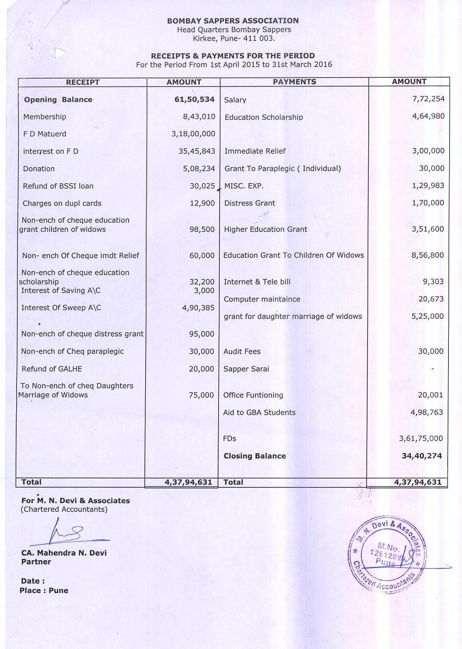
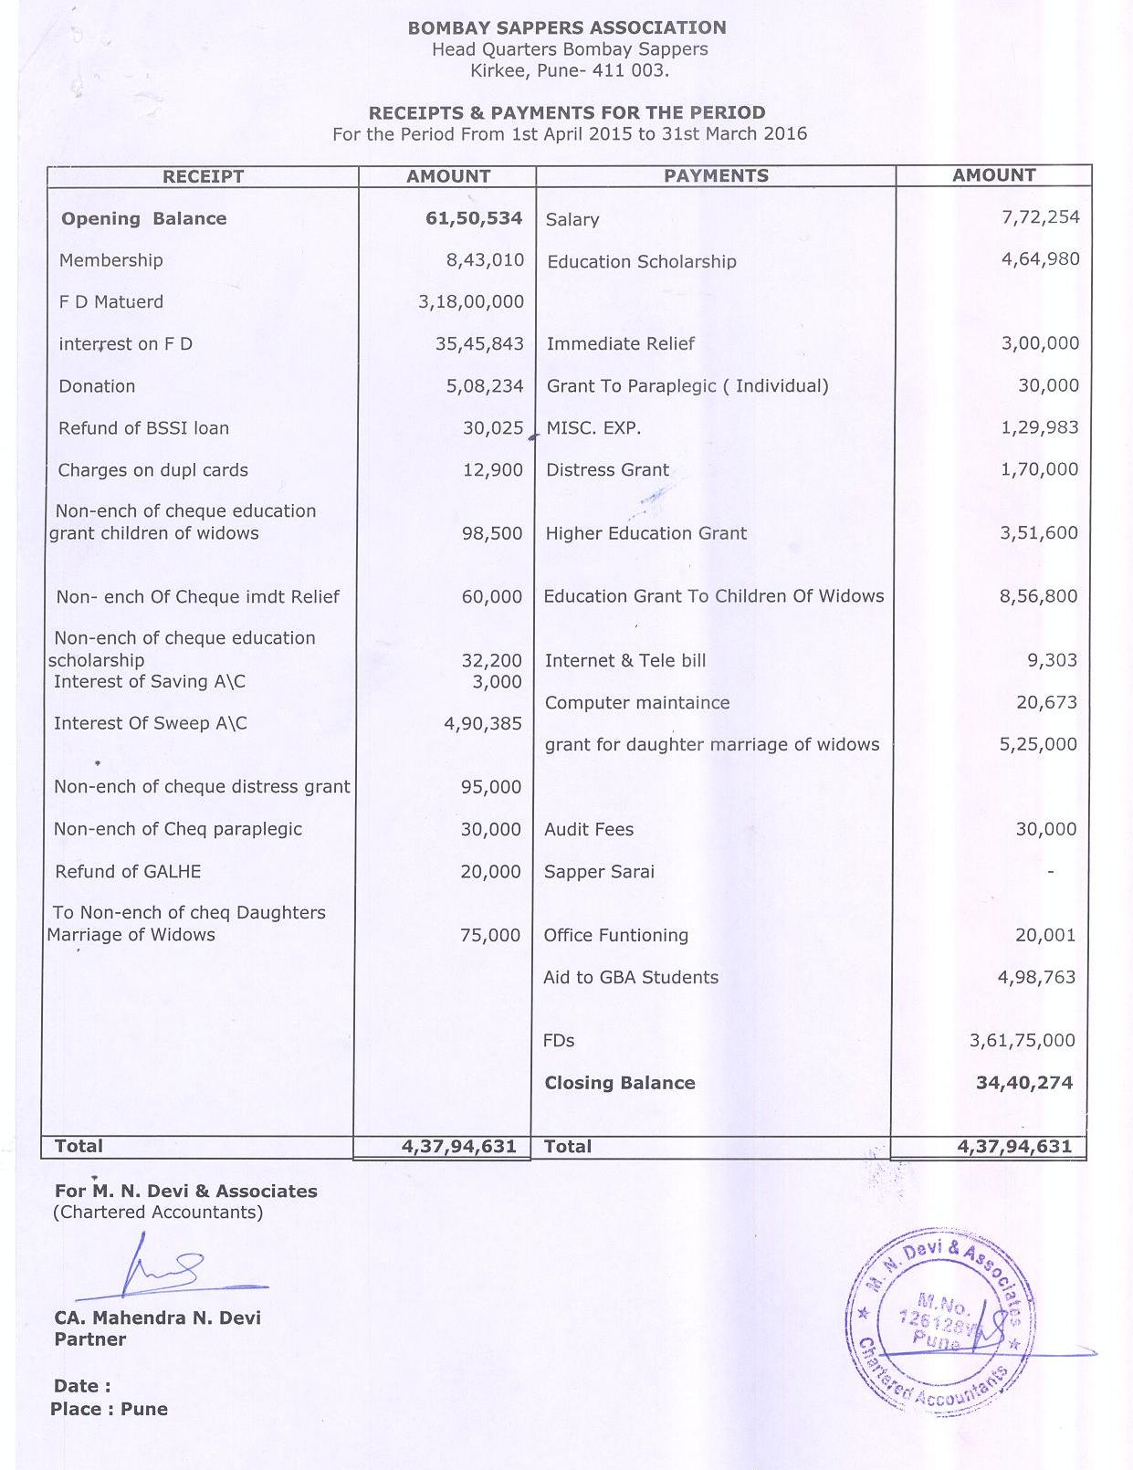
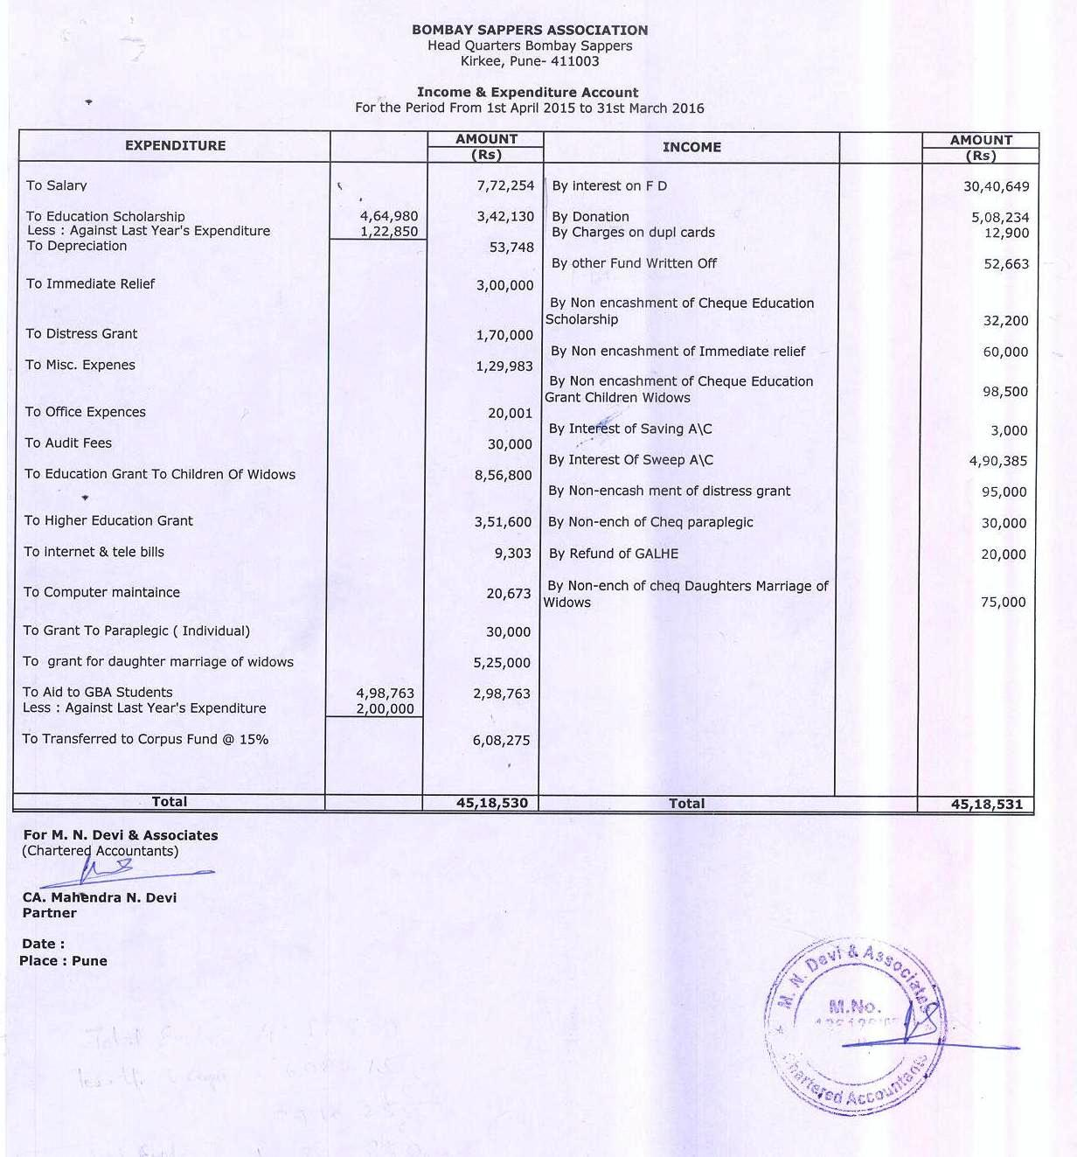

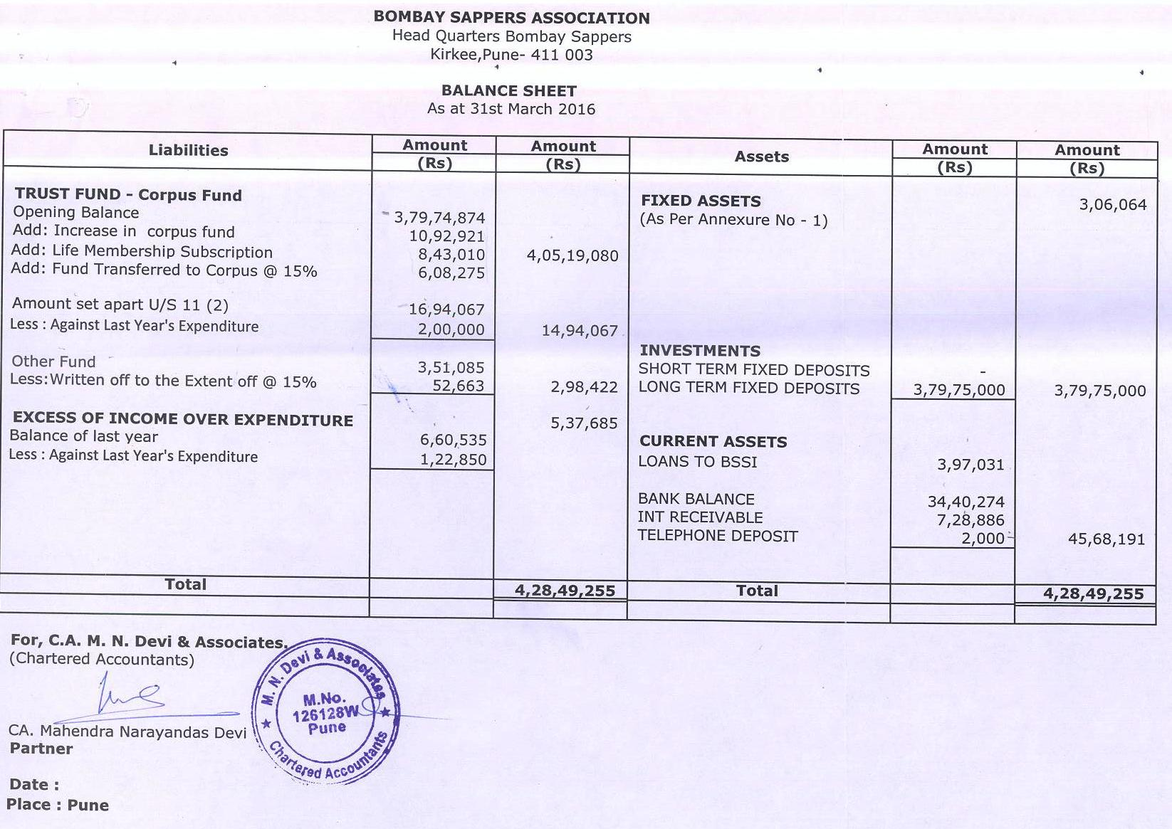

16. Some members queried about large amount being taken as income due to non encashment of cheques. The director clarified that now validity of cheques is only 3 months and some time delays occurred in nodal units receiving the cheques and physically handing them over to the beneficiaries. This has been over come from this year by asking for details of bank accts including IFSC code at the application stage and maximum disbursal is being done through bank transfers.

17. Director also drew the attention of members to the increase in corpus value from Rs. 3.79 crore to 4.04 crore. He said that our fixed deposit were Rs. 3.79 crore hence there is scope to increase the fixed deposit in the current financial year, which could be done some were in 3rd quarter after assessing the expenditure of current year.

Review of annual budget 2016-17 to be presented in AGM.

18. Anticipated Income for Fy 2016-17. The same was displayed on a slide which is tabulated below:-.

Ser No | Head of Income | Income  FY 15-16 | Anticipated Income FY 16-17
1 | Interest from FDs | 35,45,843.00 | 28,80,562.00
2 | Interest from Sweep | 4,90,385.00 | 4,00,000.00
3 | Income from duplicate card charges and Interest from saving A/c | 15,900.00 | 25,000.00
4 | Donations | 5,08,234.00 | 7,00,000.00
 | Total | 45,60,362.00 | 40,05,562.00

19. The director informed that figures of interest on FDs is on actual as per details worked out (which were show on a slide and the same is given at appx ‘A’). This year the anticipated income due to interest has reduced drastically and hence there is a requirement to collect more donations. An anticipated figure of Rs. 7 lacs has been taken for which he requested all members to help him getting more donations this year. He informed that an amount of Rs. 54,600/- has been received so far as donations, in this Fin year.

20. Proposed Budget FY 2016-17. The director displayed the proposed allotment based on anticipated income of Rs. 40 lacs on a slide which is tabulated below: -

Ser No | Head of Expdr | Expdr  2015-16 | Proposed allotment/  anticipated expdr
1 | Edn Scholarship | 4,64,980.00 | 4,75,000.00
2 | Edn Grant (Children of widows) | 8,56,800.00 | 8,75,000.00
3 | Distress Grant + Imdt Relief | 4,70,000.00 | 5,00,000.00
4 | Grant for Marriage of Daughters of widows | 5,25,000.00 | 5,00,000.00
5 | GALHE | 3,51,600.00 | 3,40,000.00
6 | Salary | 7,72,254.00 | 8,00,000.00
8 | Maint of Cmptr | 20,673.00 | 23,000.00
9 | Tele Bill/Internet | 9,303.00 | 15,000.00
10 | Office Expdr | 20,001.00 | 20,000.00
11 | Audit Fees | 30,000.00 | 32,000.00
12 | Misc | 1,29,983.00 | 25,000.00
13 | Aid to GBA students | 4,98,763.00 | 4,00,000.00
 | TOTAL | 41,49,357.00 | 40,05,000.00

21. Member queried whether we will fall short of funds, for our welfare measures due to lack of income this year. It was also discussed whether we should borrow from the corpus to overcome the short fall this year. The Hony Gen Secy pointed out that we should as far as possible not borrow from the corpus, in fact we should always aim to increase the corpus value. The director pointed out that we have sufficient bank balance as on 31 Mar 2016 and we are financially quite sound and hence the situation of borrowing from corpus should not arise, In fact we should aim to match the amount of fixed deposit with our value of corpus by increasing the fixed deposits in FY 2016-17. The situation of actual expenditure on various welfare schemes can be reviewed in 3rd quarter, when most of the boards for welfare schemes get concluded, and a clear picture emerges.

Donation received from Capt. Raghesh Dasannacharya (Retd).

22. The director informed that Capt Raghesh Dasannacharya (Retd), a SSC Officer who retired from TB-1 in 1999, contacted the BSA and wrote a letter on Apr 16 (attached at appx ‘B’) which was displayed. The Officer has donated an amount of Rs 2.5 lac and desired the same be used as follows:-

(a) Rs. 25,000/- be given to GBA for buying the books for the library.

(b) Rs. 2.25 lacs should be held in fixed deposit by BSA and out of the interest received each year, a scholarship in the name of his mother “Indira Dasannacharya” be instituted. The amount of interest received should be awarded to one or more meritorious students of GBA.

23. BSA thus asked GBA to fwd a proposal to institute the scholarship. The proposal received from GBA was displayed and explained to the MC. The same is given below: -

(a) Interest of approx Rs. 13,500/- (on fixed deposit of Rs 2.25 lacs) to be distributed to wards of widows every year as follows:-

(i) Two best student of Class 5th to 6th
(ii) Two best student of Class 7th to 8th.
(iii) One best students of Class 9th to 11th
(iv) Total scholarship of Rs. 13,500/- to 5 students (@Rs. 2,700/- each)
(v) Overall %age of marks to be 75% or above.
(vi) In case no eligible candidates’ found award would be given to class topper of each class/stream commencing from class 5th to 10th.
(b) Books worth Rs. 25,000/- to be purchased.
24. Proposal from BSA for institution of Indira Dasannacharya Scholarship. Based on the proposal received from GBA the director recommended that the donations received be utilized as under: -

(a) Rrecommendation from BSA for utilisation of Rs. 25,000/- .

(i) BSA to fwd cheque of Rs. 25,000/- for purchase of books as proposed. (However books like guides /annual issues should not be purchased out of this fund)

(ii) GBA to complete purchases and fwd list of books purchased along with copy of receipt for info of Donor.

(iii) All books should have bold labels “Indira Dasannacharya Scholarship Fund”.

(b) Recommendation from BSA for utilisation of Rs. 2, 25,000/-

(i) GBA to order a board to select best students (from wards of widows) as soon as schools reopens in June.

(ii) Students should be selected based on performance of past year in following fields:-

    - Academic performance.
    - Performance in Sports and co-curricular activities.
    - Discipline of child throughout past year.

(iii) Name of selected children should be fwd to BSA by 31 Jul each year.

(iv) BSA to fwd a consolidated cheque of interest, received that year, to GBA.

(v) GBA to give out “Indira Dasannacharya Scholarship” during the Independence Day function.

(vi) GBA to fwd photographs of students receiving “Indira Dasannacharya Scholarship” to BSA.

(vii) BSA to fwd photograph and names of awardees to Donor.

25. The proposal of BSA to manage and institute the “Indira Dasannacharya Scholarship” was accept in totality.

BSA Life membership to TA pers of 175 Engr Regt (TA)

26. Director brought out salient points about 175 Engr Regt (TA) which has been raised .These were as follows:

(a) 175 Engr Regt (TA) was raised in 2015.
(b) 85% of unit comprises of TA pers who are serving as part time soldiers.
(c) Maximum of these TA persons are from the state of J&K.
(d) Main task of this regt is maintenance of the Border Fencing on the LOC
27. Director also informed that one TA personnel had died during an operational task and the unit has written to BSA to give his NOK immediate relief as given in other cases.

28. The case of, whether BSA life membership should be offered to these TA personnel, was discussed at length and initial view was that, as TA pers of the Rly TA units of the Bombay Sappers have not been given BSA membership, the same should be followed in this case. It was pointed out in the discussion that pers of Rly TA unit are permanent employees of the railways, whereas these pers of 175 Engr Regt (TA) unit are basically unemployed youth of J&K. It was also brought out that as there is a frequent embodiment and disembodiment the exact strength will be very large and some of them will serve for very short periods and thereafter will have no connect with the BSA /Bombay Sappers. It was finally decided that director should get more details of the strength and periods of employment, also which record office maintains their documents etc so that a final decision can be taken on this point.

29. However it was decided unanimously that the NOK of the person who has been martyred should be given the Imdt relief grant of Rs10, 000/-, even though he is a TA personnel and not a member of the BSA. However this should be treated as a special case as a onetime measure and should not become a precedent for future cases.

Rotation of Management Committee members

30. Director informed that as per the decision taken in the last MCM letters and emails were sent to all officers (BSA members) settled down in Pune for volunteering /recommending names to join the BSA management committee. These were in addition to letters sent earlier to all units and senior serving and retired officers of the Bombay sappers. In response to all these, following responses were recd:

(a) Letters received from 267 ER & 122 ER with no recommendations

(b) Five letters/emails received from members recommending the name of Brig S Dandekar (Retd), ex director of BSA for induction in the MC

(c) One email recd from Lt Col PB Keskar, (Retd) recommending the name of Col TG Shankar (Retd) for induction in the MC

(d) One letter was received from Brig Sandeep Desai, presently serving as ACE in Southern Command. The officer has volunteered to join the MC after his superannuation in October 2016.He also made some suggestions in his letter which were as follows:

(i) 20% of existing members of MC to be replaced every year

(ii) Tenure of member should not exceed 5 yrs

(iii) A management committee member could be considered for re nomination after a break of one year (AGM to AGM).

31. Director informed that Brig S Dandekar (Retd) was contacted but he has expressed his inability to join the MC. However Col T G Shankar has given his willingness to join if selected.Hony Gen Secy brought out that suggestions given by Brig S Desai were good and could be followed. However the Vice Chairman brought out that changing one member with longest tenure every year may not be feasible and also not desirable. In this way we will be changing the Hony Gen Secy every year. He felt one member should be changed after every two years so that we will gradually change all members of the MC. It was also discussed that we have three retired Officers and one retired JCO in the MC which should be kept in mind.

32. It was finally decided that the one veterans officer should be changed every two years so that the senior most who will be Hony Gen Secy will get min two years tenure. The JCO member should be turned over after every six yrs.

33. Maj Gen SCN Jatar said that he would like to step down after the AGM on 15 July2016 and suggested that Maj Gen S D Sohoni should replace him as the Hony Gen Secy. He suggested that Maj Gen SG Pitre who is an invitee member can be inducted as a regular member in the MC. In that case there may be no need to induct a fresh member in the MC this year. He also said that decision taken about methodology of rotation of members of MC should be got ratified in the AGM on 15 July16.

Misc Points from Members

34. Pre recruitment Camp. Camp was organized for giving pre recruitment training to the wards of widows in 268 Engr Regt at the behest of Brig BK Kohli (Retd), Dir BSA (NR). The camp was success with 56 children attending the same.

35. Establishment of a new Website: Col Mohit Nangia gave information about an EME Centre’s website which is interactive with its members seeking employment and the industries who wish to employ ESMs. He brought out that the website was comprehensive with large number of good features and suggested that we should also have a similar web site. It was brought out that we need to go in details of our requirements and needs. It should also be seen if our own BSA web site can be upgraded to make it interactive. The costs will also be required to be worked out. The Vice Chairman felt that there is a need for such a website and we should cater for an amount of Rs1 lac in the budget for 2016-17. The Director said that it will be incorporated by increasing the figs of anticipated donations to Rs8lacs. He again reiterated that we will have to make efforts to collect more donations this year.

36. There being no other points, the meeting was declared closed thereafter.

Sd/-XXXX (Brig S R Mazagaonkar, Retd)
Dir, BSA
10002/MCM/BSA

Bombay Sappers Association
C/O Headquarters
Bombay Engineer Group & Centre
Kirkee, Pune-411003

09 Jul 2016

Distribution:-
Chairman. The Bombay Sappers Association
Vice Chairman., Secy-Cum-Treasurer
Honorary Gen Secretary, All members of the Management Committee.
Dir BSA Northern Region, All Bombay Sappers Units
Website of BSA
Appx’A’
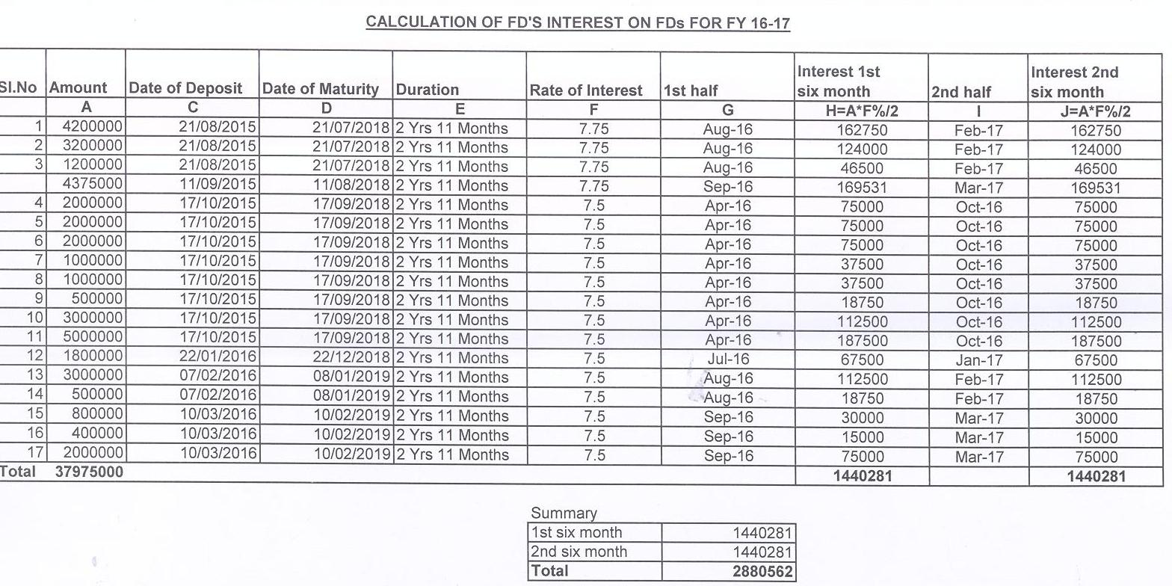

Appx’B’
