BOMBAY SAPPERS ASSOCAITION
MINUTES OF 43rd MANAGEMENT COMMITTEE
MEETING (MCM) HELD ON 02 SEP 2014

1. 43rd meeting of the Management Committee of Bombay Sappers Association (BSA) was held on 02 Sep 2014 at 1100 hrs in the Hall of Generals at BEG & Centre. The meeting was chaired by Brig Anurag Bhasin, Vice-Chairman, Comdt BEG & Centre, Kirkee, Pune-03.

- Following were present:-
(a) Maj Gen SCN Jatar (Retd) - Hon Gen Secy
(b) Maj Gen S D Sohoni (Retd) - Member
(c ) Maj Gen S G Pitre - Member
(d) Brig S R Mazagaonkar (Retd) - Director, BSA
(e) Col MM Bhushan (Retd) - Member
(f) Col Anil Negi - Secy -cum –Treasurer
(g) Col Mohit Nangia - CO Depot Bn
(h) Maj Sandeep Saini - OIC BSA
(j) Sub Maj (H’ Capt) Lawate - Member
(k) Sub Maj Nasim Khan - Asst Secy

3. Maj Gen S G Pitre proposed a welcome to the new Director Brig S R Mazagaonkar (Retd) who assumed the appointment on 11 Aug 2014 and wished him all the very best in his endeavors.

Agenda for MCM

4. The Director gave out the agenda of points to be discussed in this MCM.
(a) Approval of Mins of the 42nd MCM (last MCM).
(b) Expenditure state till 31Aug 2014.
(c) Review of Budget 2014-15.
(d) Misc. Pts
(i) Grant of ESM Status to recruits boarded out medically with 100% disability.
(ii) Distress grant to Ex Nk Nural Hasan for daughters marriage as a spec case.
(iii) Collection of Rs 500/- from JCOs and Hony Lts on promotion.
(iv) Distress grant for civ staff of the Bombay Sappers Officers’ Mess .
(v) Resolve issue of clerk for the BSA.
(vi) Appeal for donations.
(vii) Any other point from members.

Approval of Min of 42nd MCM

5. Dir proposed that Mins of 42nd MCM (Last MCM) be approved. The minutes were approved unanimously. Director also briefed the management committee about the actions completed on decisions taken in the 42nd MCM.

Contd…2/-
-2-

6. Strength of members, who have paid membership fees, as on 01 Jun 2014, is:-

(a) Offrs - 1412
(b) JCOs - 2406
(c) ORs - 40892
(d) Total - 44710

7. Expenditure State as on 31 Aug 2014

Ser No | Head of expdr | Budgeted amt 2014-15 | Expdr during Aug 14 | Total Expdr till 31Aug 14 | Remarks
1 | Edn Scholarship | 6,50,000 | - | 5,800.00
2 | Edn Grant for Children of widows (EGCW) | 14,00,000 | - | 29,900.00
3 | Distress Grant + Imdt Relief | 6,00,000 | 64800 | 169800
4 | Grant to Paraplegic | 50,000 | - | -
5 | Grant for Marriage of Daughters of widows | 50,000 | - | 20,000.00
6 | GALHE | 2,50,000 | 20,000 | 20,000
7 | Sport Grant | 1,00,000 | - | -
8 | Salary | 7,11, 000 | 25,850 | 2,64,720
9 | Maint of Cmptr | 17,000 | - | 11,997
10 | Tele bill/Internet | 9,000 | - | -
11 | Office Expdr | 20,000 | - | 2,000.00
12 | Audit Fees | 28,000 | - | -
13 | Depreciation | 85,000 | - | -
14 | Misc | 30,000 | 926 | 2125.00
15 | Aid to GBA |  | 4,12,096 | 4,12,096
 | Total | 40,00,000 | 5,23,672 | 9,38,438.00

Contd…3/-

-3-

Review of Budget 2014 -15

8. Director explained that the review of the budget approved in the 41st MCM has
been necessitated due to the following:
  - Decision to abolish sports grant
  - Decision to increase marriage grant to Rs 25000/-(from Rs10000 )
  - Decision to give grant to GBA to subsidise annual expdr of students
  - Decision to purchase E –rickshaws
  - Proposal for addl funds to sapper sarai.
  - Necessity to buy comptrs for BSA as existing two comptr on loan from Depot Bn are being withdrawn being of old vintage.

9. Anticipated availability of funds for the year 2014-15 is as under:
(a) Interest from FDs Rs 38, 32,498
(b) Donation Recd to-date Rs 72,700
(c) Misc Income(Dupl cards)to-date Rs 9,974
(d) Surplus Funds Fin yr 2013-14 Rs 5, 95,265
(e) Anticipated donations Rs 1, 50,000
___________
Total Rs 46, 60,437
Say Rs 46, 60,000
Contd…4/-

-4-
10. The proposed amended budget is as under :-
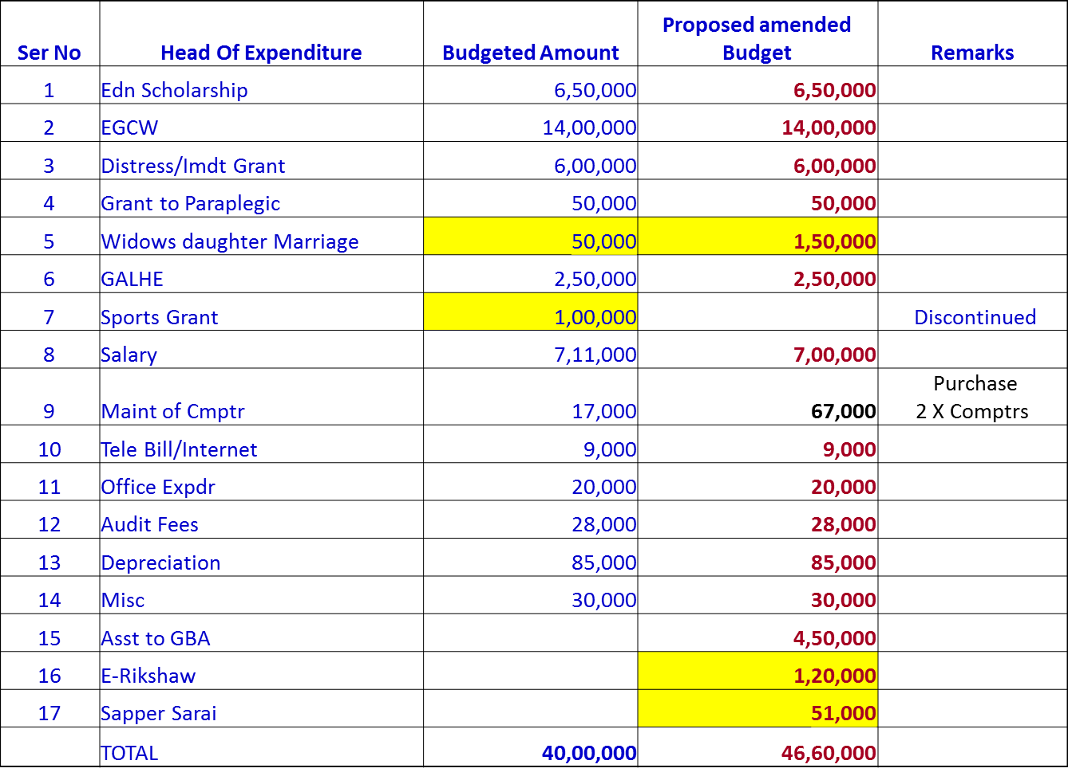

11. The proposed amendments in the budget were approved after discussions during which the following points emerged.

(a) All efforts should be made to increase donations because we will be using the entire surplus funds from last yr in this proposal. Also with increased donations we would be in a position to cater for additional funds required for the Sapper Sarai and buying E-Rickshaws for welfare of men.
(b) Director should write to all officers who regularly donate to BSA and request for donations.
(c) Director Northern Region should be requested to get donations through his contacts.
(d) All major units should donate Rs 10,000/- every year as has been agreed in a previous AGM. Vice Chairman said that he will write to all the Commanding Officers after the Col Comdt’s consent.
(e) Donors often insist that their donations be utilized only for personnel of their units.This should be discouraged in future.
(f) While it was agreed that BSA should buy one Desk Top PC, one Lap Top and a printer, Hony Gen Secy advised that we should buy good branded eqpt.
Contd…5/-
-5-
Miscellaneous Points

12. Grant of ESM status to recruits medically boarded out with 100% disability. Director informed that as per an Army HQ letter dated 07 July 14, all rects boarded out with 100% disability are to be treated as ESM for all practical purposes. He requested members to deliberate and decide whether we should also treat them as members of BSA. As of now BSA membership is given only after a rect successfully completes his training and becomes a soldier trainee (ST). It was decided that we should, without any doubt treat all such persons as members of BSA, including past cases where they have not been formally been made paid members. However from now onwards Record Office should be informed to intimate details of such cases to BSA,so that such recruits can be made paid members and issued BSA cards when they come to TB-1/TB2 for clearance.

13. Distress Grant as a spec case to Ex Nk Nural Hasan of 109 ER for daughter’s marriage. This individual had directly petitioned the COAS for fin asst in Jan 2014 and the case has been sent to BEG & Centre and then to BSA via EinC’s branch. The chairman pointed No of such cases have increased and individuals are approaching the Commandant’s office for financial assistance. As per BSA charter we give assistance for daughter’s marriage, only to widows of BSA members. After discussion it was decided that BSA will not take any action. The case be fwd to 109 Engr Regt to assist the individual if possible and E-in-C’ Br be informed accordingly.

14. Distress grant to civilian staff of the Bombay Sappers Officers’ Mess. The chairman brought out that most of the civilian staff in the mess has spent their whole life time with us and as such they, for all practical purposes , have become a part and parcel of the Bombay Sappers. Hence he proposed that we create a Corpus/earmark some funds through which financial assistance can be given to them. All the members agreed with the idea but it was decided that a separate letter be written to all the Bombay Sappers Officers (serving and retired) through the Officers Mess for donations. The corpus so formed should be part of the officers mess account. Moreover it was felt that if grant is given through the BSA, a precedence will be set and other civilian staff of BEG may also ask for similar provisions.

15. Collection of Rs 500/ - from JCOs and Hony Lts on promotion. Director explained that all individuals pay Rs1000/- on becoming Soldier Trainees and are made BSA members. However on promotion to JCOs the difference of Rs 500/-(membership fees of JCOs is Rs1500/- and of Officers is Rs2000/-) is not being collected. After some deliberation following was decided.
(a) Record office should be informed to endorse copy of promotion orders of all Havs to Nb Sub. BSA should write to respective units asking them to ask the newly promoted JCOs to deposit Rs 500/- and send old cards along with fresh photographs of JCOs in uniform so that fresh BSA cards can be issued.
(b) Hony Lts need not pay Rs 500/- as they are not accorded all the privileges of an officer such as membership of the offrs’ mess etc. However the units should send their old cards along with photographs in Hony Lt uniform for renewal and they should be charged only Rs 50/- for the new card as per the existing practice.
(c) All personnel who become RCO will however be asked to pay the difference in membership fees.
(d) This should be implemented with imdt effect
-6-
16. Resolve Issue of Clerk for BSA. Director explained the present position of staff in the BSA office and the urgent requirement of a clerk. The issue had been discussed in the last MCM and it was decided that one clk will be detailed and one clerk could be hired from the funds of Placement cell. CO Depot Bn explained that the proposal for hiring of a clk for the placement node in BEG had been turned down. The vice chairman ruled that one clerk will be given with imdt effect from the Gp HQ.

17. Appeal for Donations . The point had already been deliberated upon during the discussion on the budget. However it was suggested that as there is lot of emphasis nowadays on industries to spend on CSR activities we could tap this source to get benefits for say GBA and other welfare measures for the serving and retired members of BSA. Hony Gen Secy pointed out that the methodology of giving aid through CSR is quite complicated and there are lots of restrictions on the same. He will be sending an brief on the subject through email to the director and CO Depot Bn for perusal. Director also suggested that appeal be made to all Bombay Sapper officers through the Gp Adjt email gp. Vice chairman ruled that this needs to be deliberated upon and a decision on this will be taken later.

18. Provision of Smart Classroom for Demob . CO Depot Bn asked the committee to reconsider this point (though it had been turned down in the last MCM.) He drew the attention to the fact that the present accommodation which is used by the BSA and also for conducting the classes for the demob personnel is under demolition and it will be prudent that BSA have its own accommodation. Maj Gen S G Pitre pointed out that this is not possible as BSA cannot construct on Def land. Even if this could be termed as a temp accn it is not worth spending such a big amount on construction of a shed. He also pointed out that there are so many associations of various army regiments and all of them have been accommodated within their regtl resources. BEG & Centre can easily find accommodation to house the offices of BSA. The chairman agreed with this and promised to find a suitable accommodation within the Centre for the BSA office.

19 . There being no other points the MCM was declared closed.

10002/MGT/ BSA
Bombay Sappers Association (S R Mazagaonkar)
C/o Headquarters Brig (Retd)
Bombay Engineer Group & Centre Dir, BSA
Kirkee, Pune- 411003

05 Sep 2014
Distribution:-

Chairman, Bombay Sappers Association
Vice- Chairman, Secy-Cum- Treasurer
Honorary Gen Secretary, BSA Northern Region
MCM Members, All Major/ Minor Units, BSA Web Site

